David Reese

David.reese@csuglobal.edu

trends in employer sponsored health insurance

Milestone Project

There is a potentially serious problem growing in employer sponsored health insurance. Premium increases and increases in the amount employees are asked to contribute are forcing small and medium sized businesses to cancel benefit programs, or cut them back drastically. Add to the mix increased max out of pocket amounts, and copays and the cost of health insurance becomes unaffordable to many workers. What makes this worth studying is that over seventy percent of the working population get their health insurance through an employer plan.

Facing shrinking revenues, many companies will re-design programs, re-work provider compensation, and finally raise premiums to cover the lost business. Which will cause more companies to stop offering programs, or offer a reduced benefit plan for an increased cost.

The data clearly shows this over an eight-year period, from 2008 to 2018. I used the data provided by Agency for Healthcare Research and Quality to develop the following data. I ran the numbers in SAS, and the charts were done in Excel. US_Total refers to the entire United States. Small_biz refers to companies with 50 or less employees, Medium_biz 51-99 employees, Large_biz, 100 + employees.

First, we need to look at the big picture. This shows that a majority of large firms offer some sort of employer sponsored plan, and have through the time period we are studying. Small and medium sized businesses actually saw reductions in the number of firms offering coverage. These groups make up the bulk of the firms in the U.S., which means that the type of company the majority of Americans work for, are leaving the employee to find their own plan or go onto a government exchange.

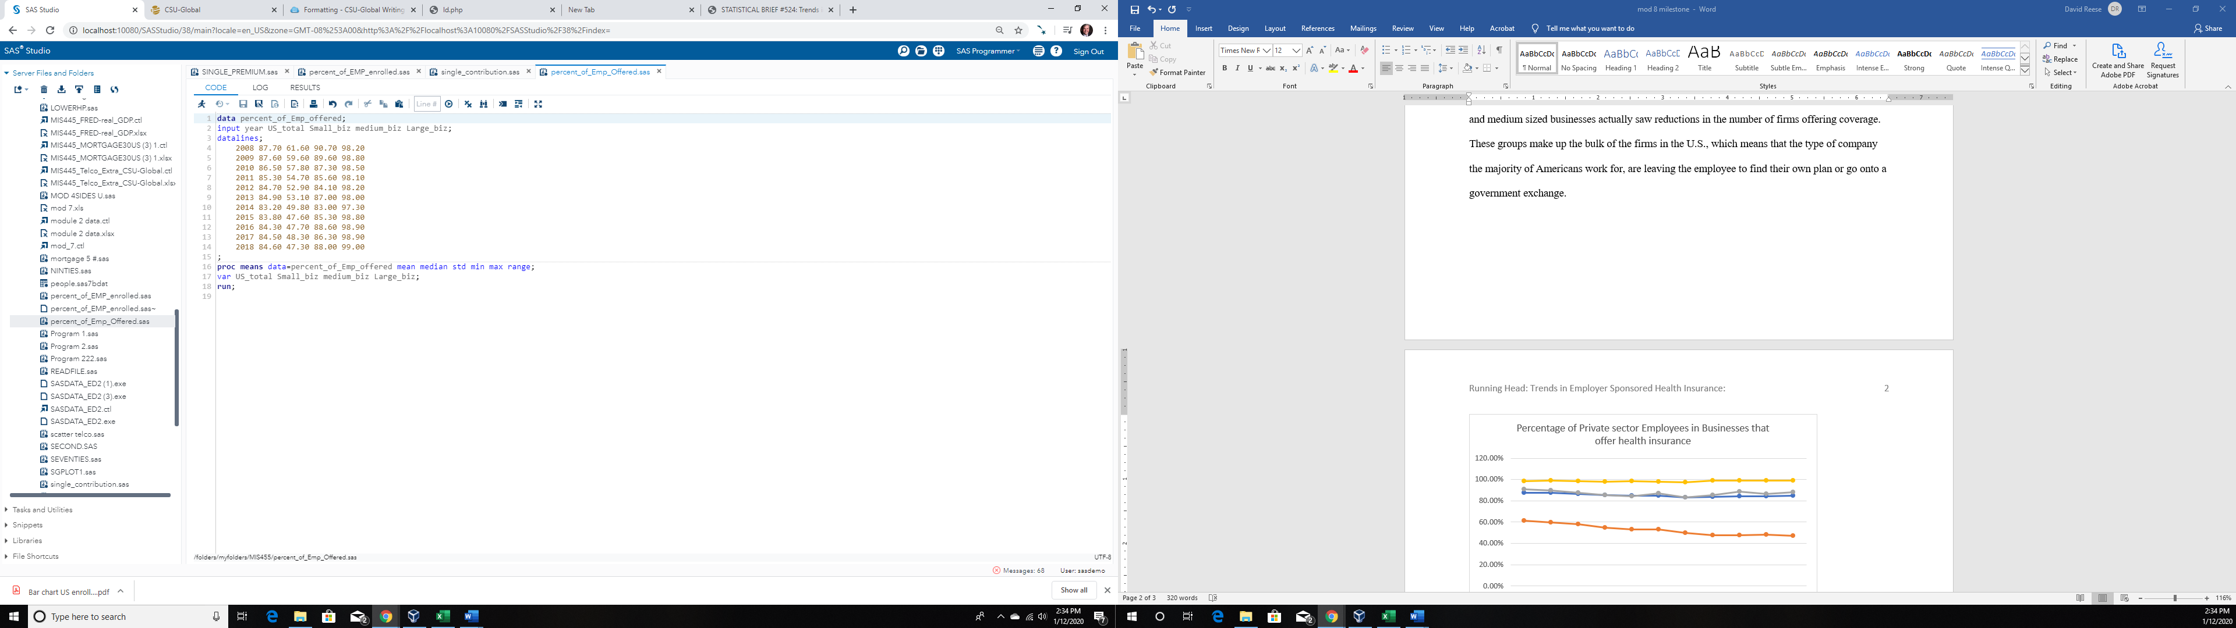

| **Variable** | **Mean** | **Median** | **Std Dev** | **Minimum** | **Maximum** | **Range** |
| --- | --- | --- | --- | --- | --- | --- |
| US_total  Small_biz  medium_biz  Large_biz | 85.1909091  52.7636364  86.8636364  98.4272727 | 84.7000000  52.9000000  87.0000000  98.5000000 | 1.4720425  5.1470910  2.3161488  0.5217105 | 83.2000000  47.3000000  83.0000000  97.3000000 | 87.7000000  61.6000000  90.7000000  99.0000000 | 4.5000000  14.3000000  7.7000000  1.7000000 |

While most companies offer plans, we see fewer employees taking advantage of the plans. Over the 8 years studied, the number of employees enrolled dropped across all the categories.



| **Variable** | **Mean** | **Median** | **Std Dev** | **Minimum** | **Maximum** | **Range** |
| --- | --- | --- | --- | --- | --- | --- |
| US_total  Small_biz  medium_biz  Large_biz | 49.7909091  30.4090909  47.4272727  58.0818182 | 49.4000000  30.3000000  46.9000000  57.7000000 | 2.3951846  3.7766267  2.8618494  1.8808605 | 47.2000000  26.5000000  44.3000000  56.0000000 | 53.9000000  36.8000000  53.8000000  61.3000000 | 6.7000000  10.3000000  9.5000000  5.3000000 |

One reason for the reductions in both the number of firms offering coverage and the people enrolling is premium. In the 8 years studied premiums climbed, along with the out of pocket costs of deductibles and co-pays. Looking at just a single person’s premium, we can see the increases clearly.

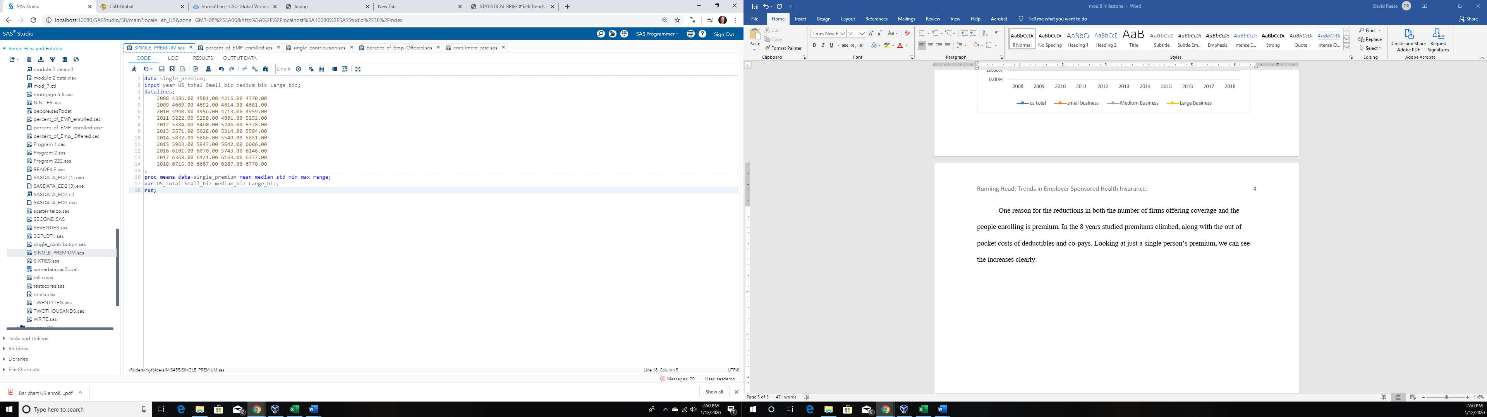

| **Variable** | **Mean** | **Median** | **Std Dev** | **Minimum** | **Maximum** | **Range** |
| --- | --- | --- | --- | --- | --- | --- |
| US_total  Small_biz  medium_biz  Large_biz | 5559.18  5586.00  5304.27  5579.45 | 5571.00  5628.00  5314.00  5584.00 | 722.3471213  699.4331991  654.3832349  737.0837624 | 4386.00  4501.00  4215.00  4370.00 | 6715.00  6667.00  6287.00  6770.00 | 2329.00  2166.00  2072.00  2400.00 |

Additionally, there have been increases in the amount the employee is expected to pay.

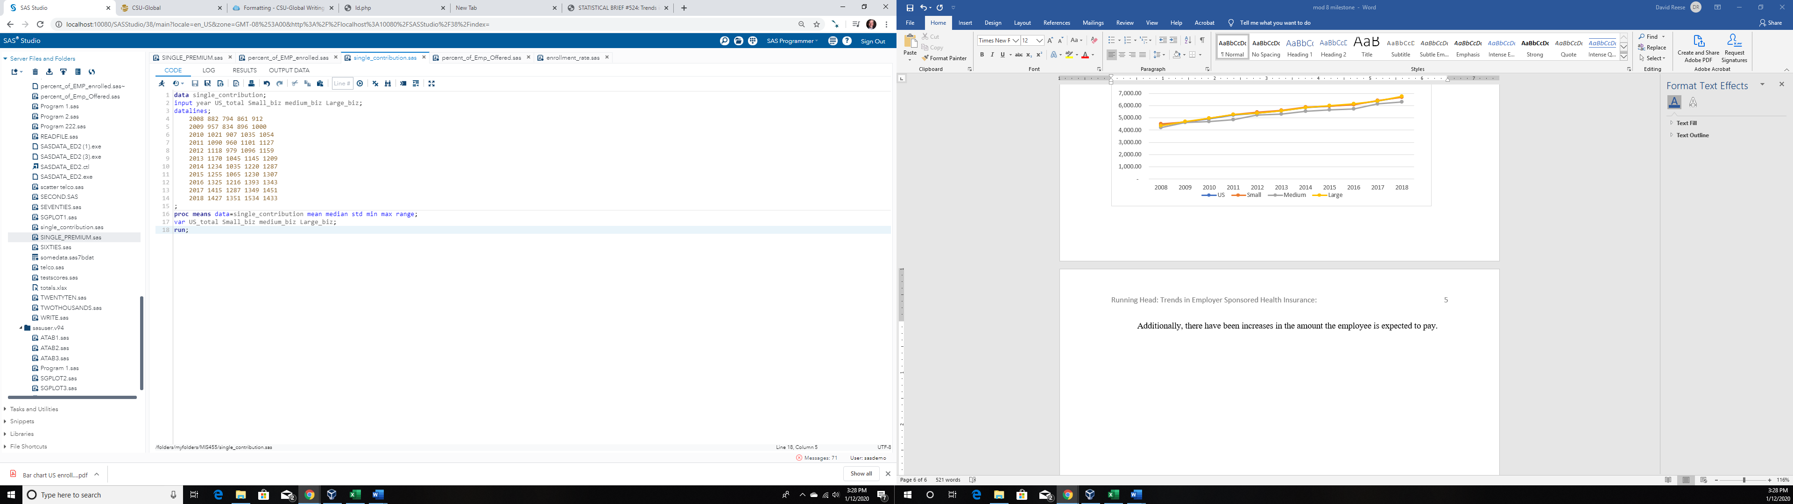

| **Variable** | **Mean** | **Median** | **Std Dev** | **Minimum** | **Maximum** | **Range** |
| --- | --- | --- | --- | --- | --- | --- |
| US_total  Small_biz  medium_biz  Large_biz | 1172.18  1043.00  1169.09  1207.45 | 1170.00  1035.00  1145.00  1209.00 | 179.1607201  178.8977362  204.9392371  175.3558460 | 882.0000000  794.0000000  861.0000000  912.0000000 | 1427.00  1351.00  1534.00  1451.00 | 545.0000000  557.0000000  673.0000000  539.0000000 |

To calculate the real cost of health insurance, we need to add the premium to the contribution amount.

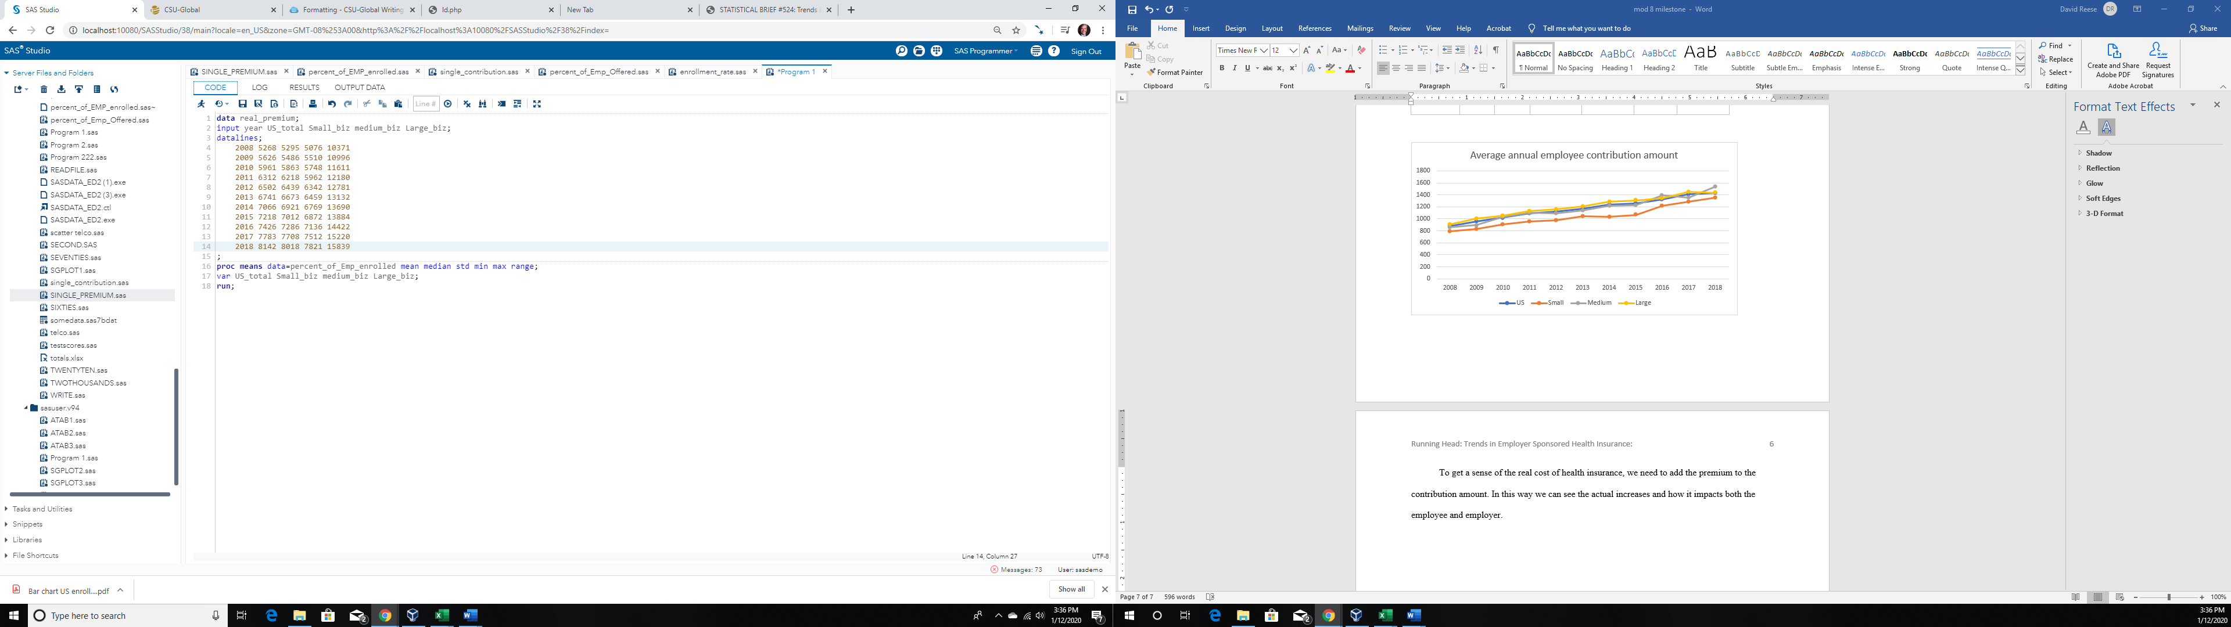

| **Variable** | **Mean** | **Median** | **Std Dev** | **Minimum** | **Maximum** | **Range** |
| --- | --- | --- | --- | --- | --- | --- |
| US_total  Small_biz  medium_biz  Large_biz | 6920.75  6817.75  7222.00  9886.00 | 7142.00  6966.50  7136.00  13787.00 | 958.2508991  916.0913476  441.0232420  6557.07 | 5268.00  5295.00  6769.00  2009.00 | 8142.00  8018.00  7821.00  15839.00 | 2874.00  2723.00  1052.00  13830.00 |

It seems clear that the problem will only grow based on the data. It is clear that despite the promises of all of the different regulations and new legislation, that this is not getting any better soon.

If we wanted to see what the data predicts we would want to do a two tailed test. The hypothesis I would test would be :

Null Hypothesis: Costs of employer sponsored health plans will stay flat

Alternative hypothesis: Costs will go up

|  |  |  |  |  |  |
| --- | --- | --- | --- | --- | --- |
| **Mean** | **95% CL Mean** | | **Std Dev** | **95%**  **CL Std Dev** | |
| 5559.2 | 5073.9 | 6044.5 | 722.3 | 504.7 | 1267.7 |

|  |  |  |  |  |  |
| --- | --- | --- | --- | --- | --- |
| **N** | **Mean** | **Std Dev** | **Std Err** | **Minimum** | **Maximum** |
| 11 | 5559.2 | 722.3 | 217.8 | 4386.0 | 6715.0 |

|  |  |  |
| --- | --- | --- |
| **DF** | **t Value** | **Pr > |t|** |
| 10 | 25.52 | <.0001 |



1

0

Quantile

-1

4500

5000

5500

6000

6500

**Q-Q Plot of US_total**

US_total

8000

6000

4000

95% Confidence

0

10

20

Normal Kernel

30

**Distribution of US_total**

With 95% Confidence Interval for Mean

The outcome shows that the Null Hypothesis is rejected. The code is saved in my SAS library titled work.

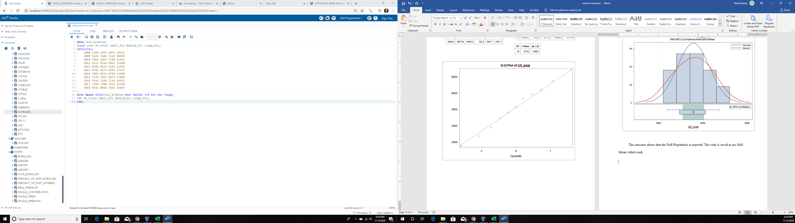

References

<https://meps.ahrq.gov/data_files/publications/st524/stat524.shtml>